
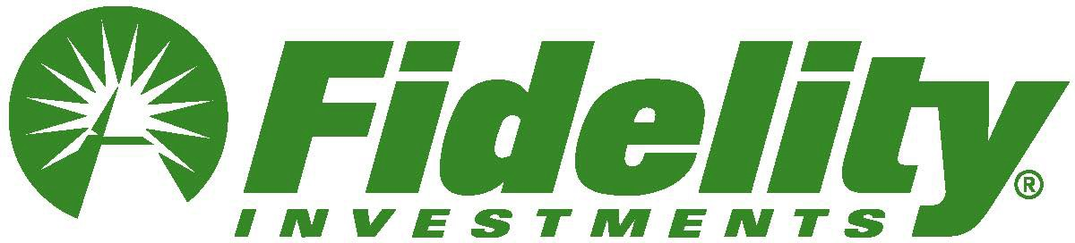
Subject: Learn how to get more from your money

Preheader: Strategies for retirement saving, managing your money, and leaving a legacy.



How to take your money to the next level & create a financial legacy
Take your money to the next level with on-demand workshops from Fidelity.
Get help:
- Making the Most of Your Retirement Savings
- Managing My Money
- Preserving Your Savings for Future Generations

Watch now

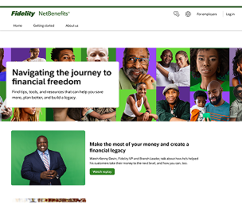

Find additional insights, tools, and strategies at Fidelity.com/Blacklegacy

Privacy Policy Terms of Use

Investing involves risk, including risk of loss.

The information in this email is intended solely for the attention and use of the named addressee.

This message or any part thereof must not be disclosed, copied, distributed, or retained by any person without authorization of the addressee.

Please do not respond to this email. This mailbox is not monitored, and you will not receive a response.

The third-party trademarks and service marks appearing herein are the property of their respective owners.

Fidelity Brokerage Services LLC, Member NYSE, SIPC, 900 Salem Street, Smithfield, RI 02917

© 2025 FMR LLC. All rights reserved. 1181863.5.0

